**Guided Capstone Project[Big Mountain Resort] Report**

**Findings and Recommendations**

Big Mountain Resort is trying to find a price strategy, so that the price reflects the market dynamics in the ski mountain resorts in the nation and offer value to customers equivalent to the facilities it has. Using Random Forest modeling, price was determined by a comparative model of different ski mountain resorts and the details of their facilities. Adult-weekend prices was used for modeling. Some of the features that were used to predict the ticket price were vertical drop, snow making in acres, number of total chairs, fast quads, number of runs, longest run-in miles and skiable terrain in acres. Of them, it was revealed that four features such as fast quads, number of runs, snow making acres and vertical drop had significant impact on price. Figure-1 shows the level of importance the features have on price. Figure 3 shows the correlation effects how these variables relate to ticket prices.

**Figure 1**

The modeled price for the Big Mountain Resort is $98.07, compared to current price of $81, the modeled price is 19% higher than the current price. The modeled price has a mean average error of $10.46. Hence, it advised that a price for Big Mountain Resort may range between $ 86 and $ 106. We can suggest that given the premium brand that has been built already and the vast number of facilities that it possesses compared to other resorts in the nation (such as skiable terrain area, snow making area, number of runs etc.) charging a price of $96 may do justice for the market dynamics evidenced from the modeling process. However, this price should be implemented with caution as it might bring down the demand for Big Mountain Resort by next year. Currently, it is expected that there will be 350, 000 visitors. But we need to adjust this number as per the new modeled price.

In this process we have couple of scenarios in consideration.

1. **Scenario 1-Decrease in Runs:** Based on the number of runs, if we increase the Runs by 1, there is not any changes in the price, but with further decrease there is a reduction in price and hence a reduction in revenue too. Closing more than 6 runs causes a signification reduction in price and inturn reduction in Revenue
2. **Scenario 2-increase in 1 Run, increase the vertical drop by 150 and total chair increase by 1:** The price is reduced by 1.55, and the revenue is increased by 2708333
3. **Scenario 3-Decrease in 1 Run, increase the vertical drop by 150 and total chair increase by 1 and 2 acres of Snow Making area:** The price is reduced by 1.55, and the revenue is increased by $2708333. No change in the price and hence the revenue because of the increase in the snow making area
4. **Scenario 4-Increasing the longest run by .2 miles and increasing 4 acres of Snow Making area: There is no change in price**

Although state specific features (population and area in square miles in relation to each resort facilities) were considered initially, since they didn’t show any pattern with the prices, they were dropped later in the analysis. The conclusion was arrived at the modeled price by using resorts operating in different states; however, it should be noted that operating costs may differ at different states. For example, the labor cost, and maintenance cost in New York may be higher than that in Montana where the Big Mountain resort is. This could be one of the reasons why we got a very high modeled price compared to the current price as we treated resorts from like in California, New york and Montana the same. Along with this, taking the vast number of facilities (this is comparatively high for Big Mountain resort) into the modeling process, also soared the price to $98.07.

Along with this we have an assumption of just the weekday and weekend prices , but we have not taken into account seasonality. The weekend prices during summer, Christmas and holiday season is not given separately.

Figure-2 shows the distribution of prices in each state. Hence, it would be better if we take state specific effects into account, most importantly, the costs in different states should be considered.

The Model also does not talk about expenditure .The whole pricing is based on the predictions owing to the facilities and not the expenses.

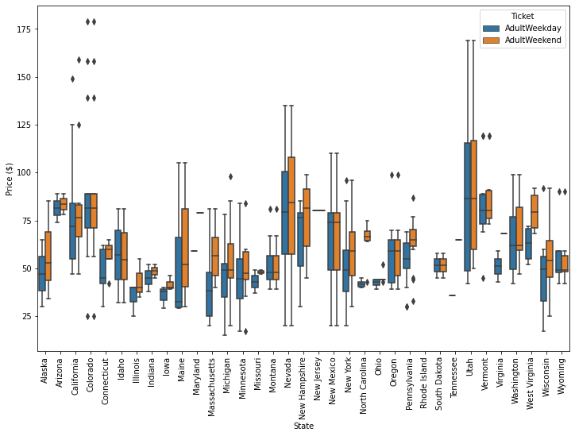

**Figure 2**

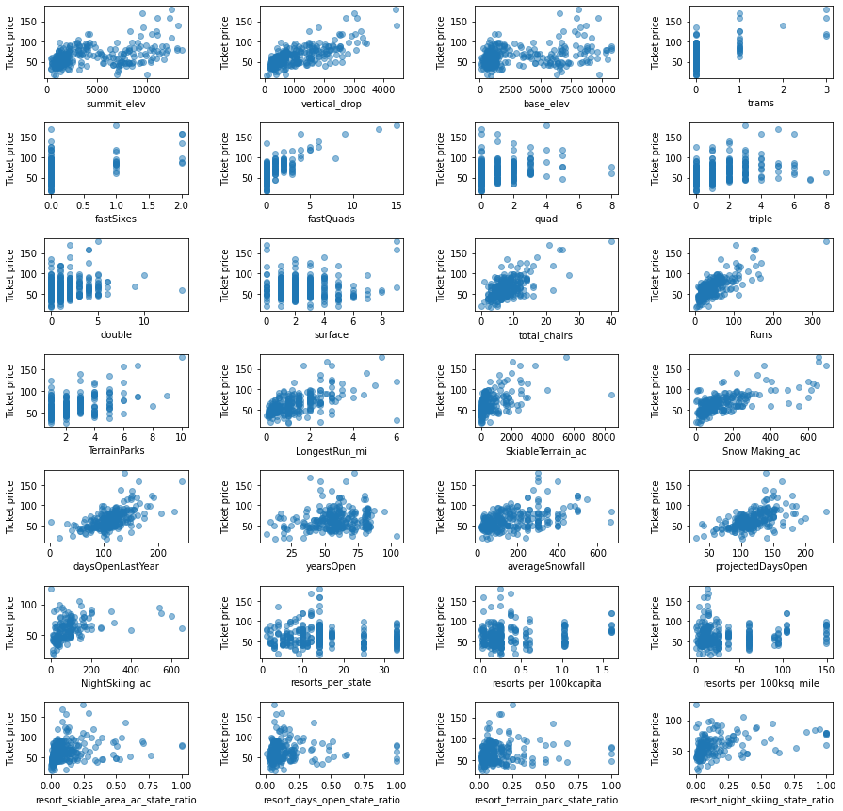

**Figure 3**